**OUTPUT:**

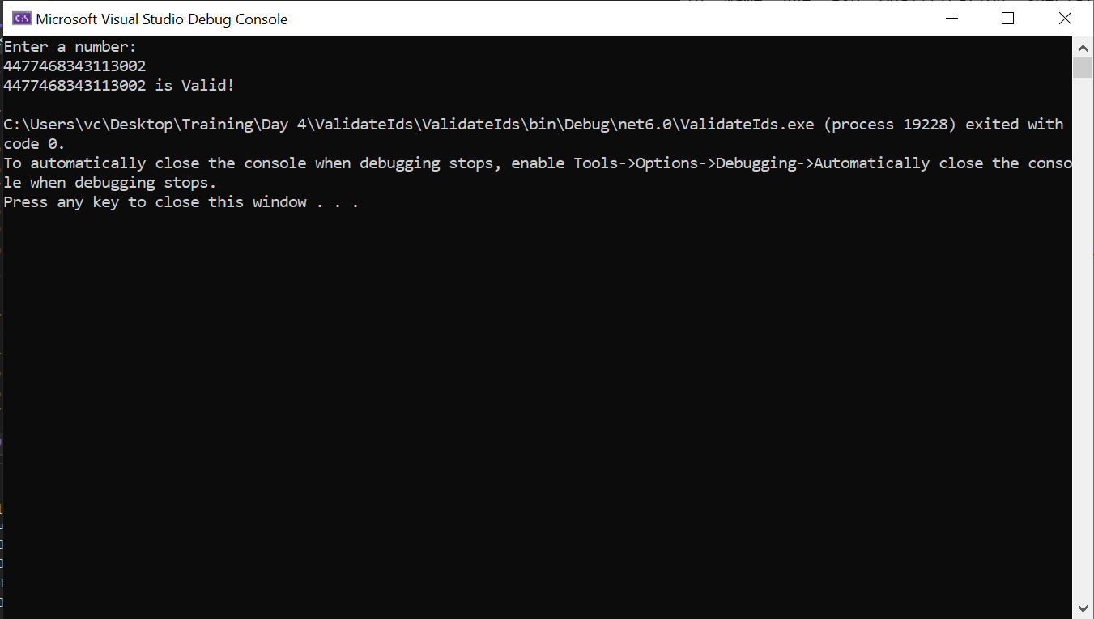

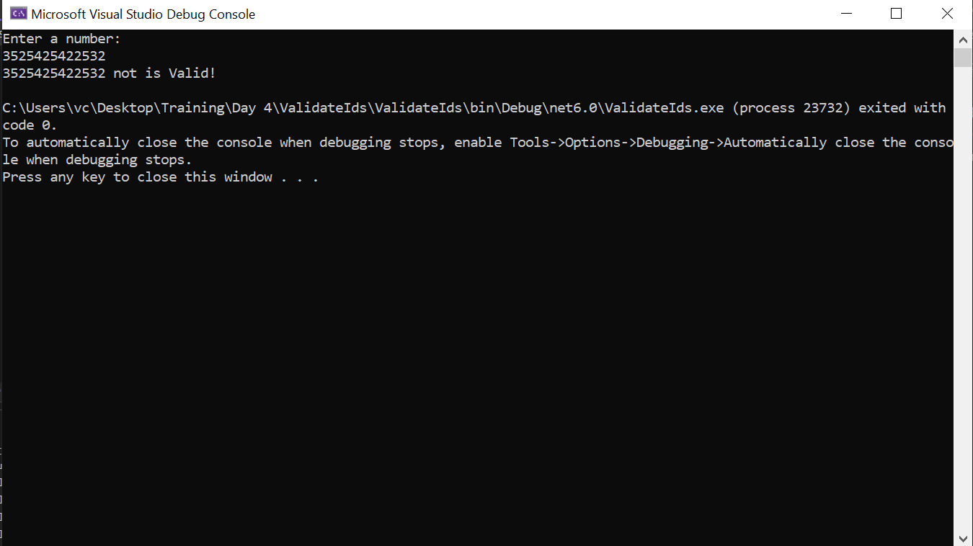

**CODE:**

using System.Net.Sockets;

namespace ValidateIds

{

class Program

{

/// <summary>

/// Get Digit sum if it is two digit number or return number by multiplting it by 2

/// </summary>

/// <param name="digit">Digit as (int)</param>

/// <returns></returns>

static int GetDigitSum(int digit)

{

digit *= 2;

return digit < 10 ? digit : digit / 10 + digit % 10;

}

/// <summary>

/// Function that validates Id and return bool

/// </summary>

/// <param name="id">Get id as (long)</param>

/// <returns></returns>

static bool ValidateID(long id)

{

int c = 1;

long rev = 0;

while (id > 0)

{

int digit = (int)(id % 10);

if (c % 2 == 0)

{

digit = GetDigitSum(digit);

}

rev += digit;

id /= 10;

c++;

}

if (rev % 10 == 0)

{

return true;

}

return false;

}

/// <summary>

/// Function to get Long Input

/// </summary>

/// <returns></returns>

static long GetLongInp()

{

Console.WriteLine("Enter a number:");

long id;

while (!(long.TryParse(Console.ReadLine(), out id)))

{

Console.WriteLine("Invalid Entry! Try Again..");

}

return id;

}

static void Main(string[] args)

{

long id = GetLongInp();

if(ValidateID(id))

{

Console.WriteLine($"{id} is Valid!");

}

else

{

Console.WriteLine($"{id} not is Valid!");

}

}

}

}